BACKEND PROGRAMS
SKILL – 2 :
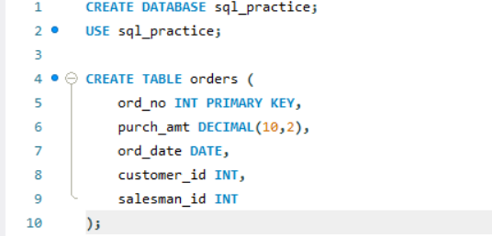

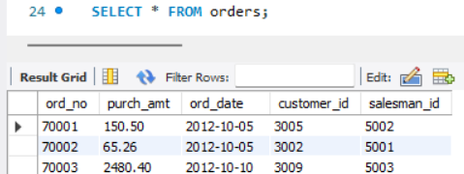
Q1 — WHERE
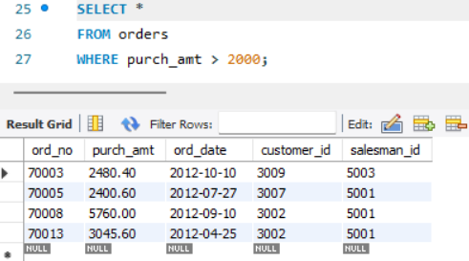
Q2 — ORDER BY
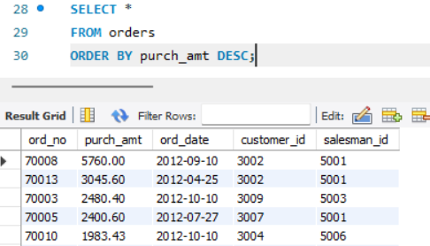
Q3 — SUM()
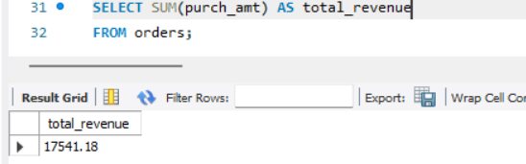
Q4 — AVG()
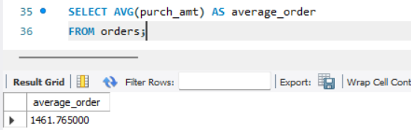
Q5 — GROUP BY
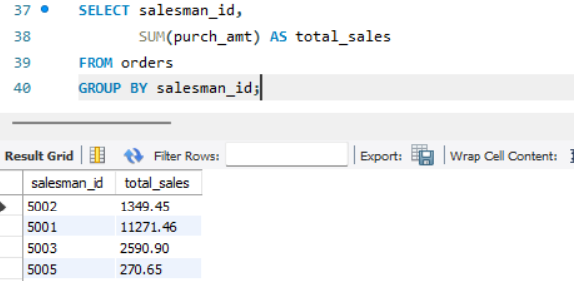
Q6 — GROUP BY + HAVING
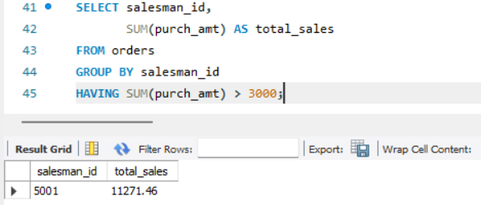
Q7 — COUNT + HAVING
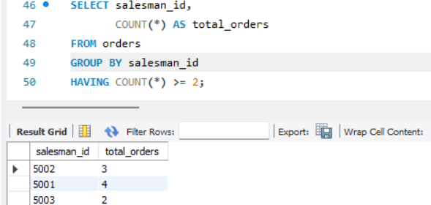
Q8 — BETWEEN + HAVING
